

École des Ponts ParisTech

2014-2015

Pierre Cuvilliers

Cours

Titre

Table des matières

1. Conception des coques et toiles tendues 5

1.1. Équivalence tension-compression, intérêt de la méthode 5

1.2. Surfaces minimales, présentation, propriétés 5

1.3. Forces extérieures 5

1.4. Surfaces connues 5

2. Recherche de surfaces à courbure constante 6

2.1. Notations 6

2.2. Hypothèses de base, justifications 6

2.2.i. État de contraintes 6

2.2.ii. Discrétisation, maillage 6

2.3. Forces sur un élément de surface 6

2.4. Équilibre d’un nœud dans le repère local 6

2.5. Équilibre d’un nœud dans le repère global 6

3. Résolution numérique, algorithme 7

3.1. Point fixe 7

3.2. Gradient 7

3.3. Convergence 7

3.3.i. Justification 7

3.3.ii. Critère d’arrêt 7

3.4. Pseudo-inverse 7

3.5. Remise à jour qs 7

3.6. Implémentation 7

3.6.i. Boucles 7

3.6.ii. Erreur numérique 8

4. Forces extérieures 9

4.1. Câbles 9

4.2. Pression : idem 9

4.3. Gravité : idem 9

5. Grasshopper 10

1.1. Images, utilisation générale 10

5.1. Entrées 10

5.2. Sorties 10

5.3. Visualisations 11

5.4. Exemples 11

5.5. Verifications 11

# Conception des coques et toiles tendues

## Équivalence tension-compression, intérêt de la méthode

## Surfaces minimales, présentation, propriétés

* État de contraintes uniforme
* Courbure moyenne
* Problème de bord type « bulle de savon »

## Forces extérieures

* Pression + Gravité
* Câbles

## Surfaces connues

* PH
* Caténoïde
* Schwartz
* Plat avec câbles
* Coussin gonflé
* Isler, Kapoor, ILEK, Mantra, Tanz-Brunnen

# Recherche de surfaces à courbure constante

## Notations

## Hypothèses de base, justifications

### État de contraintes

* Tension pure + isotrope
* Densité de contrainte

### Discrétisation, maillage

* FEM masquée
* Tension uniforme vs. Taille différente des mailles
* Différentes formes possibles via qs(i)

## Forces sur un élément de surface

## Équilibre d’un nœud dans le repère local

## Équilibre d’un nœud dans le repère global

# Résolution numérique, algorithme

## Point fixe

## Gradient

* Inversion de matrice
* Méthode de Newton ?
* Instable ? Vitesse d’approche

## Convergence

### Justification

* Lemme de Banach
* Dérivée partielle vs dérivée totale (article)

### Critère d’arrêt

* Résidu forces vs déplacement
* Adimensionnement

## Pseudo-inverse

## Remise à jour qs

* Équilibre des tensions

## Implémentation

### Boucles

* Nœuds
* Itérations positions
* Itérations qs

### Erreur numérique

# Forces extérieures

## Câbles

* Intérêt : poutres de rive, fixation toiles
* Force, équilibre repère local, équilibre repère global
* Algo point fixe

## Pression : idem

## Gravité : idem

# User manual

## Features

Kroto is a membrane form-finding tool for Rhino 5 / Grasshopper. It is based on the surface stress density method, open-source[1], and written in Python. It is specifically aimed at finding the form of a membrane in equilibrium under a set of predefined loads, such as:

* isotropic membrane stresses, uniform (minimal surfaces) or not;
* uniform pressure;
* uniform vertical load;
* edges constraints (cables, fixed points).

However, it is not a structural analysis software and so will not output physically meaningful force and stress values nor will it find the behavior of the form-found membrane under a new set of loads (“live loads”) disrupting its equilibrium. Only the position of the points on the membrane in its equilibrium state have a meaningful value; while forces and stresses are directly proportional to the chosen stress-density coefficient, this coefficient does not have a direct physical interpretation.

Kroto does not take into account second-order effects such as:

* bending stiffness;
* material non-linearities;
* non-isotropic membrane stress states, i.e. no shear stress.

Kroto only accepts valid triangular Rhino meshes as input.

Kroto was written by Pierre Cuvilliers with Lionel du Peloux and Cyril Douthe at the Laboratoire Navier, École des Ponts ParisTech. It is part of the THINkSHELL project[2].

## Installation

### Dependencies

To use Kroto, you will need:

* Rhino 5: <http://www.rhino3d.com/download>. At the time of writing, Rhino 5 for Mac does not support Grasshopper, so Windows only (or run it from Rhino, at your own risk[3])! Rhino 5 SR9 recommended.
* Grashopper (again, see note 3 on page 10): <http://www.grasshopper3d.com/page/download-1>. GH 0.9.0075 recommended.
* GH Python: <http://www.food4rhino.com/project/ghpython?ufh>. GH Python 0.6.0.3 recommended.
* Kroto:

To ease the workflow, it is recommended you also install the following Grasshopper plugins:

* TT Toolbox: <http://www.food4rhino.com/project/tttoolbox?ufh>. Used for the legend display.
* Weaverbird: <http://www.giuliopiacentino.com/weaverbird/>. Helps creating meshes in Grasshopper.

### Installation

To actually install Kroto, you need to extract the “Libraries” and “UserObjects” folder in Kroto_1.X.Y.zip to the “settings” folder of Grasshopper.

You can find the Grasshopper settings folder from Grasshopper: File > Special Folders > Settings folder; and from Rhino by running the command GrasshopperFolders and choosing Settings. Windows will ask you if you want to merge the folders (you should answer yes) and, if you had a previous version installed, if you want to overwrite the files (in that case, you should answer yes too).

After extracting the files, do not forget to reload Grasshopper into Rhino, if it was still loaded when extracting. To do that, run GrasshopperUnloadPlugin from Rhino (save current work first), and launch Grasshopper again. You could also quit and reopen Rhino, but you might also fix all your computer problems if you [try turning it off and on again](https://www.google.com/search?q=have+you+tried+turning+it+off+and+on+again).

## First run

### Files

Kroto consists of five Grasshopper user objects (see Figure 5.1) and three supporting library files. The Grasshopper user objects are:

* Solver: solves the problem defined earlier, using the provided options. Calls the meshminimize module.
* Problem: defines a Kroto problem to solve, based on a triangular mesh, external forces, and edge conditions.
* Edges: defines the edge conditions for a mesh, using cables and fixed points.
* Options: Provides the default options, and allows to change them.
* Mesh closest points: small helper components that finds the vertices of a mesh that are closest to a set of points.

If the installation went well, you should find the user objects in the THINkSHELL tab

And the Python module files are:

* Meshminimize.py: the solver itself.
* Meshminimizehelper.py: defines some helper functions, mainly for initialization.
* Vectorworks.py: defines vector and matrix calculus functions, in 3D and arbitrary dimension.
* In the sources, you will also find main.py, which can be used to run Kroto directly from Rhino, although this is undocumented.

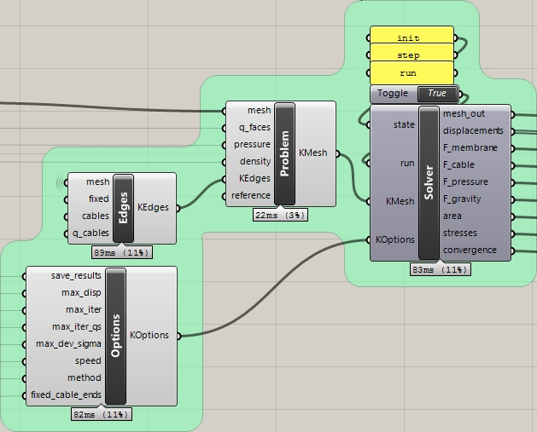

Figure 5.1: The four main Kroto components.

One of the simplest working definitions you can use to run Kroto is an inflated flat square mesh. Using only default options and no referenced Rhino geometry, it is defined by Figure 5.2. Below is a step-by-step explanation:

* First, we create a flat meshed square with the mesh plane component from Grasshopper.
* Then we triangularized this mesh as Kroto only accepts triangular meshes.
* This mesh, and the pressure value of 1.0 are passed to the Problem user object; density defaults to 0 and the edge conditions (KEdges) default to fixed (all naked vertices are pinned). The surface stress density coefficients default to 1.0.
* We then pass this problem to the Solver box, and initialize it with the string init (without quotation marks) in the state input. Defaults options are assumed (KOptions), see 5.4 for more explanations.
* Then we pass the string run to the state input, and the boolean True to the run input, running the form-finding algorithm for one pass (that is, 10 positions iterations ran for 2 stress density coefficients iterations, or until the maximum displacement in one iteration is less than 0.01 units). At this point, you should see something similar to the image at the top-left of Figure 5.2.
* Since the default options stop the algorithm quite early, it might be a good idea to run it again from the result mesh by drawing one of the input lines to Solver again.

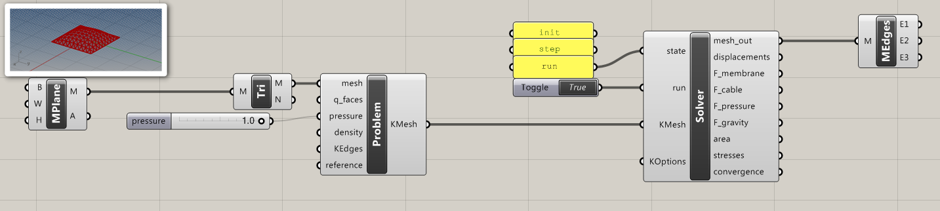

Figure 5.2: Grasshopper definition for a simple inflated square.

As a rule of thumb, a mesh with 100-200 vertices should be enough to describe usual membrane shapes. Running it for 100-400 positions iterations (max_iter) and 1-10 (less if you are looking at true minimal surfaces, more if you are playing with external forces) stress density iterations (max_iter_qs) should be enough to get to a meaningful result. If you want to run all the iterations, whatever their result, set max_disp and max_dev_sigma as 0, however a 0.01-0.05 max_disp is usually enough to get a precision under one Rhino unit. See 5.7 for more details.

## Inputs

### Solver

#### State

Takes one of the string values init, step or run.

init initializes the solver, putting the mesh in its initial form and sending the options chosen to the meshminimize module.

step runs the solver for one (position) iteration. If the solver had exhausted the position iteration counter but not the stress density iteration counter, it updates the stress densities and reinitializes the position iterations counter.

* Mesh
* Points Fixes
* Câbles
* Q_faces
* Q_cables
* Fixed_cables_ends
* Save_results
* Max_disp
* Max_iter
* Max_iter_qs
* Max_dev_sigma
* Speed
* Method
* Pressure
* Density
* Reference
* State
* Run

## Sorties

* Mesh_out
* Displacements
* F_membrane
* F_cable
* F_pressure
* F_gravity
* Stresses
* Area
* Convergence

## Visualisations

* Compare
* Colorize mesh
* Displacements

## Choosing the options

## Exemples

* Caténoide
* Schwartz
* Scherk
* Coussin
* ILEK
* Chapeau chinois
* Arcora

## Verifications

* Schwartz à la main (4 points)
* Exemples à solution analytique (Caténoïde, Schwartz, Scherk)
* Convergence en densité de maillage

1. Sources available on Github: https://github.com/THINkSHELL/Kroto
2. http://thinkshell.fr/
3. You can run Kroto directly from Rhino, although it is not well documented and supported. See /src/main.py for pointers.